**Contents at the backend:**

1. Add City
2. Edit City

**Edit City:** Opens a list of cities in our database. After selecting the city we want to edit:

1. Add Page
2. Edit Page
3. Delete Page
4. Add Advertisement
5. Edit Advertisement
6. Delete Advertisement
7. Add Tags
8. Delete Tags

**Add Advertisements:**

Backend should have an option called “Add Advertisement”. **Note: these ads get added only on the pages of the particular city we are editing**

**Step 1:** Add Advertisement

**Step 2:**

* All Bon Appetit Profiles
* All Just for Fun Profiles
* All Nightlife Profiles
* All Connect with Nature Profiles
* Search Result Pages
* Category Pages
* All User Profiles

**Step 3:** Upload image of Advertisement (Fixed width and variable height) and a link where the image will redirect.

Image below shows the position of ads.

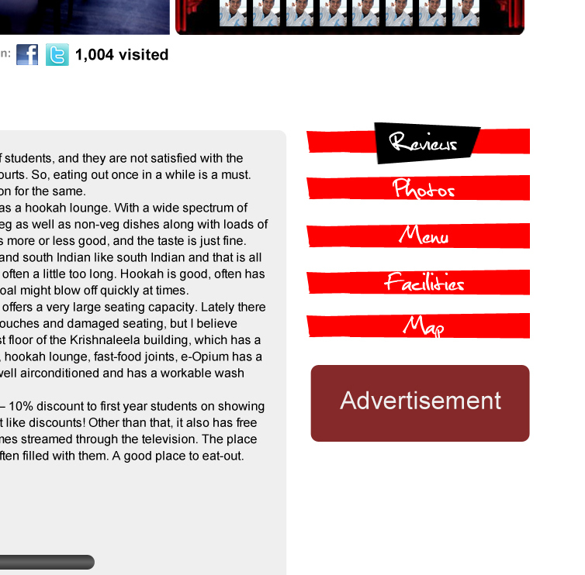

**Add Tags:**

**Step 1:**  Click “Add tags”

**Step 2:** Should be allowed to choose from:

1. Under Bon Appetit
2. Under Connect with Nature
3. Under Just for Fun
4. Under Nightlife
5. Under Features

If any of 1-4 is chosen then the tag gets added as an option on all the backend of cave profiles. It also gets added as an option to choose in the advanced search options in the search result pages.

If 5 is chosen then the user is asked to upload a image for the facility to be added and the option is added on all the backends of cave profiles.